How to download/install Maven in Windows ?

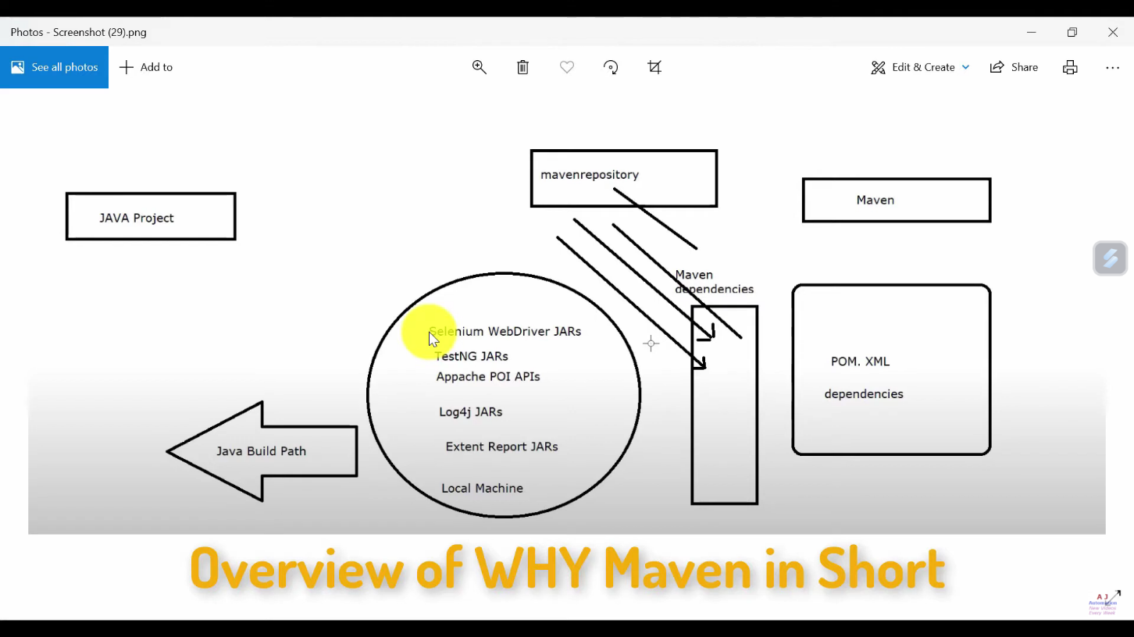

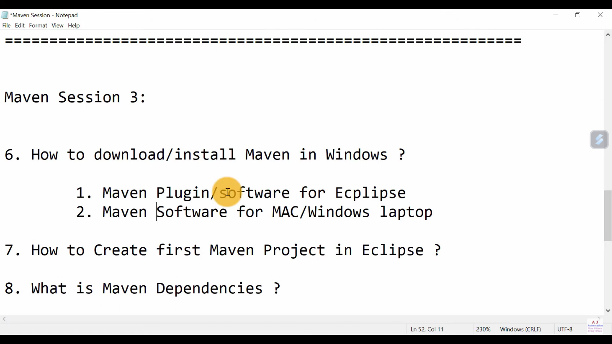

In two ways :

1. Maven Plugin/software for Eclipse(Update Maven for latest version of Eclipse):=

-Copy "https://download.eclipse.org/technolo..."

-Go to Ecplise-Help-Install New Software-Add above URL and click on Add

-Add Name and enter same URL

-Select checkbox and click on Next...Finish

-After installing, Restart ur Eclipse

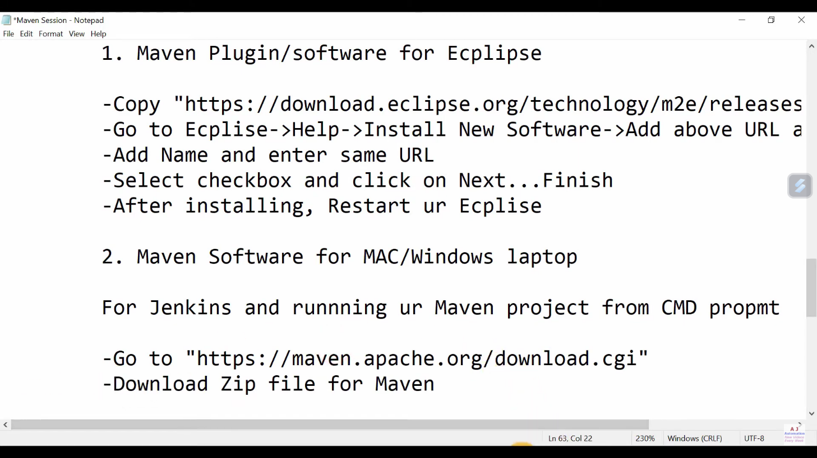

2. Maven Software for MAC/Windows laptop:=

For Jenkins and runnning ur Maven project from CMD propmt

-Go to "https://maven.apache.org/download.cgi"

-Download Zip file for Maven

-Binary zip archive apache-maven-3.6.3-bin.zip

-Setup Environmental Variables and Path

-M2_Home=C:\Users\pandi\Desktop\apache-maven-3.6.3

-Maven_Home=C:\Users\pandi\Desktop\apache-maven-3.6.3

-%Maven_Home% and %M2_Home%

-Add path upto the bin folder="C:\Users\pandi\Desktop\apache-maven-3.6.3\bin"

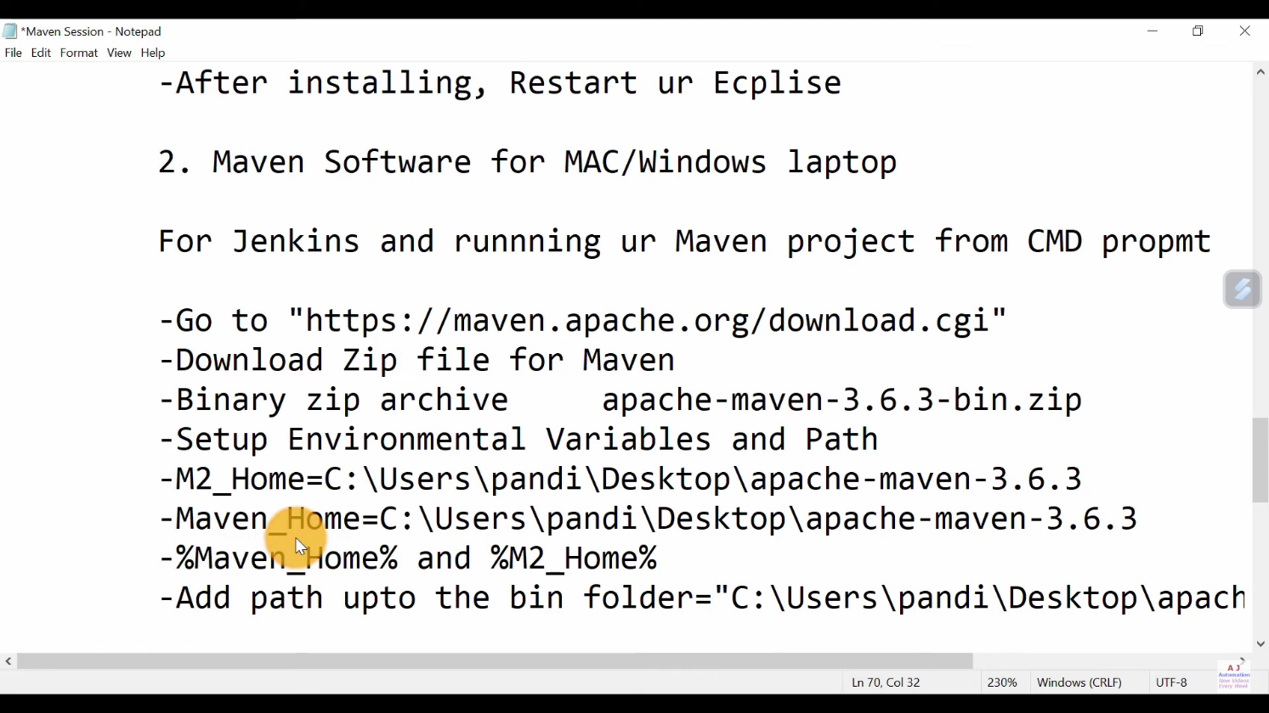

Setup dependencies in POM.xml

Go to website: https://mvnrepository.com/

Search dependencies and add 3 lines of code in POM.xml

gropup Id, Artifact Id, Version

Jars will be stored at Local Machine:(in .m2 repository)

